DET CURVES:
1D ALL CLASSES AGAINST IMPOSTOR WITH BAYES DFRT

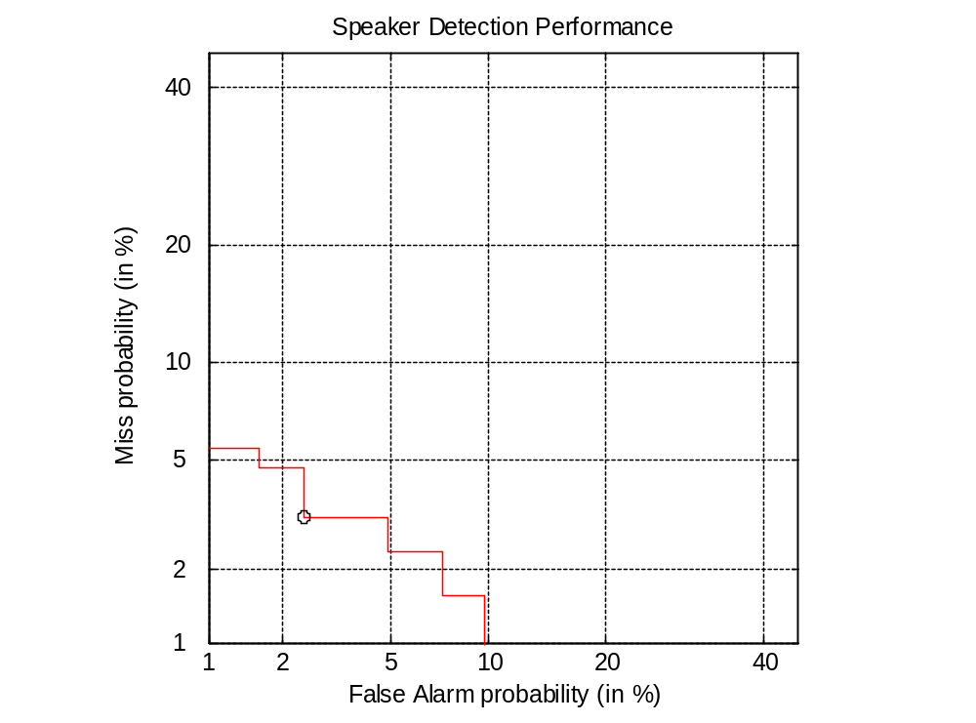
1D ALL CLASSES AGAINST IMPOSTOR WITH BAYES SAME
1D ALL CLASSES AGAINST IMPOSTOR WITH NAIVE DFRT
1D ALL CLASSES AGAINST IMPOSTOR WITH NAIVE SAME

1D ALL CLASSES AGAINST IMPOSTOR WITH NAIVE SIG2
1DOVERLAPPING ALL CLASSES AGAINST IMPOSTOR WITH BAYES DFRT
1DOVERLAPPING ALL CLASSES AGAINST IMPOSTOR WITH BAYES SAME
1DOVERLAPPING ALL CLASSES AGAINST IMPOSTOR WITH NAIVE DFRT
1DOVERLAPPING ALL CLASSES AGAINST IMPOSTOR WITH NAIVE SAME
1DOVERLAPPING ALL CLASSES AGAINST IMPOSTOR WITH NAIVE SIG2
2LINEARLY SEPERABLE FOR ALL CLASSES AGAINST IMPOSTOR WITH BAYES DFRT

2LINEARLY SEPERABLE FOR ALL CLASSES AGAINST IMPOSTOR WITH BAYES SAME
2LINEARLY SEPERABLE FOR ALL CLASSES AGAINST IMPOSTOR WITH NAIVE DFRT
2LINEARLY SEPERABLE FOR ALL CLASSES AGAINST IMPOSTOR WITH NAIVE SAME
2LINEARLY SEPERABLE FOR ALL CLASSES AGAINST IMPOSTOR WITH NAIVE SIG2
2OVERLAPPING FOR ALL CLASSES AGAINST IMPOSTOR WITH BAYES DFRT
2LINEARLY SEPERABLE FOR ALL CLASSES AGAINST IMPOSTOR WITH BAYES SAME
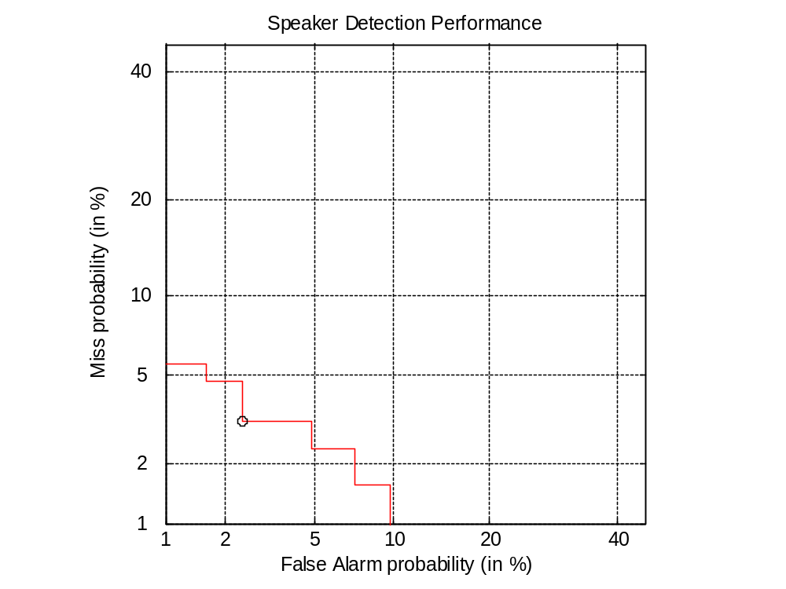
2OVERLAPPING FOR ALL CLASSES AGAINST IMPOSTOR WITH BAYES DFRT
2OVERLAPPING FOR ALL CLASSES AGAINST IMPOSTOR WITH NAÏVE SAME
2OVERLAPPING FOR ALL CLASSES AGAINST IMPOSTOR WITH BAYES SIG2

3A FOR ALL CLASSES AGAINST IMPOSTOR WITH NAÏVE DFRT
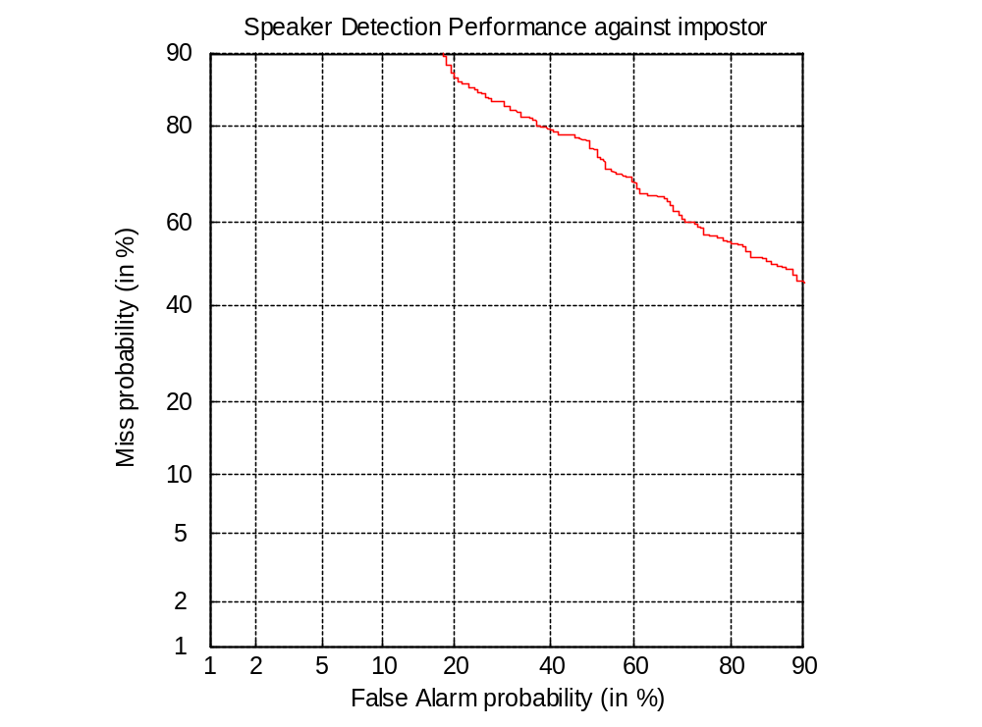
3B FOR ALL CLASSES AGAINST IMPOSTOR WITH BAYES SAME
3B FOR ALL CLASSES AGAINST IMPOSTOR WITH NAIVE DFRT
3B FOR ALL CLASSES AGAINST IMPOSTOR WITH NAÏVE SAME
3B FOR ALL CLASSES AGAINST IMPOSTOR WITH NAÏVE SIG2

3A FOR ALL CLASSES AGAINST IMPOSTOR WITH NAÏVE DFRT

3A FOR ALL CLASSES AGAINST IMPOSTOR WITH NAÏVE SAME
3A FOR ALL CLASSES AGAINST IMPOSTOR WITH NAÏVE SIG2
3A FOR ALL CLASSES AGAINST IMPOSTOR WITH BAYES DFRT
3A FOR ALL CLASSES AGAINST IMPOSTOR WITH BAYES SAME

